Chapter 1: Science toolkit

1.1 Science is the study of the natural and physical world

Student worksheet answers (pages 2–3)

What is science?

1 Which type of scientist would be the best or most appropriate one to investigate the following situations?

a A species of coral living in the Great Barrier Reef is dying unexpectedly.

A marine biologist would investigate this.

b A fossilised ancient kangaroo has been discovered in the Simpson Desert.

A palaeontologist would investigate this.

c An area of the Wilson’s Promontory National Park is drying out because of climate change.

An environmental scientist would investigate this.

d There is a possible tropical cyclone threat to northern Queensland.

A meteorologist would investigate this.

e A drug to treat a new strain of the Avian Bird Flu is needed.

A pharmacologist would investigate this.

2 Describe what this scientist might be doing.

Student responses will vary but could refer to the sampling of water, studying the organisms or chemicals in the water, and examining stream temperature or turbidity.

3 Write your own example of a situation where the following scientists would be required:

a Pharmacologist

Student responses will vary but could include developing medicine to treat a new disease.

b Palaeontologist

Student responses will vary but could include the discovery of a fossilised dinosaur.

c Environmental scientist

Student responses will vary but could include investigating the concentration of carbon dioxide in the atmosphere.

d Meteorologist

Student responses will vary but could include tracking the possible path of a cyclone.

e Marine biologist

Student responses will vary but could include investigating the diet of a whale.

f Nanotechnologist

Student responses will vary but could include developing a nanobot to treat disease.

EXTEND YOUR UNDERSTANDING

4 Find out what these scientists study. You could use the Internet or you may have a relative or someone you know who is in these fields of science.

• Zoologist

• Geneticist

• Seismologist

• Astronomer

Student responses will vary, but should note the following:

• Zoologist: specialises in animals

• Geneticist: studies features passed from parents to offspring

• Seismologist: studies earthquakes

• Astronomer: investigates planets, stars and the universe

1.2 Scientists use specialised equipment

Student worksheet answers (pages 4–5)

Lab equipment

1 Below are a series of scientific diagrams of different types of common laboratory equipment. Write the name of the equipment and a short description of how the equipment is used.

a

Beaker: used to contain liquids

b

Retort stand and boss head clamp: used to hold a probe or thermometer in a beaker

c

Measuring cylinder: used to accurately measure liquids

d

Bunsen burner: used to heat substances

e

Stirring rod: used to stir substances

f

Gauze mat: used on a tripod over a Bunsen burner

g

Evaporating dish: used to allow liquids to evaporate from dissolved solids

h

Watch glass: used to hold solids when they are being weighed

i

Funnel: used to pour liquids into a container without spillage

j

Flask: used to contain liquids so they can be safely swirled.

k

Tripod: a stand over a Bunsen burner

l

Test tube: used to contain samples

m

Thermometer: used to measure temperature.

n

Test tube holder: used to hold test tubes safely and securely

o

Test tube rack: used to store multiple test tubes

p

Spatula: used to scoop substances from a container into another vessel

q

Metal tongs: used to hold substances safely

EXTEND YOUR UNDERSTANDING

2 Research the laboratory equipment that is required for distillation.

The following equipment is required for distillation:

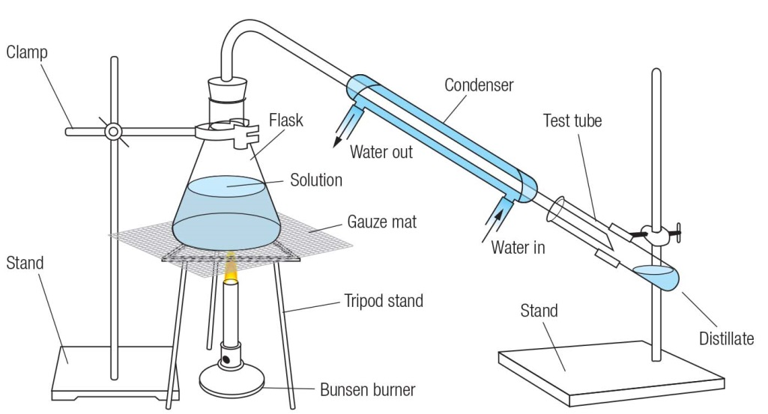

1.3 Scientists take safety precautions

Student worksheet answers (pages 6–7)

Safety in the lab

1 Read through the story below and identify as many ‘laboratory dos’ as you can. Write them in the space provided.

Two students, Rod Stirring and Connie Calflask, were preparing to conduct a simple experiment to observe the rate at which ice melts. They both listened carefully as their teacher explained the experimental procedure. Rod and Connie put on their lab coats and buttoned them up, and Connie tied her hair back. They then put their textbooks and workbooks under their desk. Rod gathered the Bunsen burner, tripod and gauze mat and placed them onto a bench mat. Connie gathered the beaker and a container of ice and placed these on the bench mat.

Rod and Connie set up the Bunsen burner equipment and placed the beaker with ice on top of the gauze mat. Before lighting the Bunsen burner, both Rod and Connie put their safety glasses on. Connie lit the Bunsen burner and they both recorded their observations.

When the ice had completely melted, they began cleaning up, but Rod accidentally knocked the beaker onto the floor and it broke. He told his teacher straight away. After the equipment had cooled down, they put it all away, washed their hands and put their lab coats and glasses away.

The laboratory dos include: listening to the teacher; lab coats on and buttoned; hair tied back; paper (workbooks and textbooks) kept away from the flame; equipment on a bench mat; correct Bunsen burner lighting procedure; safety glasses on before heating; telling the teacher when the glassware was broken; packing equipment away; and washing hands.

2 What do you think this symbol means?

The symbol means corrosive, but student may mention acids.

3 Why is it relevant to a science laboratory?

Corrosive substances, such as acids and bases, are used in a science laboratory.

4 Read through the story below and identify as many ‘laboratory don’ts’ as you can. Write them in the space provided.

Two students, Bea Kerr and Tess Tube, were preparing to conduct a simple experiment to observe the rate at which ice melts. They both listened to their iPods as their teacher explained the experimental procedure. Bea put a lab coat on, but didn’t button it up. Tess didn’t wear a lab coat because it didn’t match her shoes. Tess didn’t tie her hair back because she had had it straightened that morning. Both left their textbooks and workbooks on their bench. Bea gathered the Bunsen burner, tripod and gauze mat and placed them onto the bench. Tess gathered the beaker and a container of ice and placed these on the bench too.

Bea and Tess set up the Bunsen burner equipment and placed the beaker with ice on top of the gauze mat, but neither of them put their safety glasses on. Tess lit the Bunsen burner and they both walked away and had a chat with their friends.

When the ice had completely melted, they began cleaning up, but Bea and Tess were mucking around and knocked the beaker onto the floor and it broke. They kicked the broken glass under the bench. They picked up the equipment before it had cooled down, and both received minor burns on their hands. Both Bea and Tess left the classroom without putting all the equipment away.

The laboratory don’ts include: not listening to the teacher’s instructions; not wearing or buttoning up the lab coat; not tying long hair back; leaving paper near the flame; not placing equipment on a bench mat; not wearing safety glasses; not telling the teacher when glassware was broken; not telling the teacher after a burn; not packing the equipment away or washing hands.

EXTEND YOUR UNDERSTANDING

5 Research what these symbols mean.

The symbols, in order, are: flammable material; smoking; crane above; sudden drop; beware the dog; non-ionising radiation; strong magnets; low temperatures; cameras; electricity; loud noises; overhead load; corrosive; hazard; industrial vehicles; laser beam.

1.4 Scientists use observation and inference to answer questions

Student worksheet answers (pages 8–9)

Observation and inference

1 Beside each of the following observations, write whether they are a *qualitative* or *quantitative* observation.

a The liquid was very hot:

qualitative

b The mouse was 4.5 centimetres long:

quantitative

c The ball was travelling at 1 metre per second down the slope:

quantitative

d I heard the chemicals fizzing:

qualitative

e It took 6.7 seconds for the metal to dissolve:

quantitative

f The chemical reaction caused a 76.3°C increase in temperature:

quantitative

g I could smell the sulphur dioxide during the experiment:

qualitative

h The surface of the bench felt rough:

qualitative

i The substance turned blue when it was heated over the Bunsen burner:

qualitative

j The 50 millilitres of water evaporated from the beaker:

quantitative

2 What are three reasons why you should not smell things in a test tube unless your teacher instructs you to?

Student responses will vary but could include: the substance may be toxic, corrosive, very hot, irritating, cause allergic reactions etc.

3 Here is a picture of Dr Redback and his family (you may meet them again during your study of Chapter 5). Determine whether the following statements are observations or inferences:

a One person is sitting on a pillow on the floor:

observation

b There is a bird in the birdcage:

observation

c The cat’s name is Mr Fluffy:

inference

d The family are watching television:

inference

e There are five people in the picture:

inference

f Dr Redback is probably holding his grandson:

observation

EXTEND YOUR UNDERSTANDING

4 Find out how inferences and observations have helped scientists determine what Tyrannosaurus rex’s appearance and behaviour were like.

Student responses will vary depending on the depth of their research and the length of their response. Possible information could include the following: observations of the skeletal system and teeth can be used to determine the size and structure of a T. rex and whether it was a carnivore. Inferences would include the texture and colour of the skin, the T. rex’s diet, the sound it made, the way it walked etc.

1.5 Science relies on measuring with accuracy

Student worksheet answers (pages 10–13)

Measuring in the lab

1 Rearrange the letters of each word to work out the measurement:

a sams

mass

b tereprmueat

temperature

c dntcsaei

distance

d uvelmo

volume

e emit

time

2 Work out these clues to determine the unit of measurement:

a I wanted to meet her but I waited too long:

‘Meet her’ sounds like ‘metre’ (a homophone); ‘too long’ is a measurement of length

b Not backwards, any end:

‘Not’ backwards is ‘ton’, and ‘any’ sounds like ‘ne’, which is at the end of ‘ton-ne’

c I came first, she came third, you came where?

Second: second is between first and third

d For one cent I met really famous scientists:

‘Cent I met re’ = centimetre

e Oh you are late.

Hour: ‘oh’ becomes ‘ho’, ‘you’ becomes ‘u’ and ‘are’ becomes ‘r’

f Your gramma’s grammar is unbalanced.

Gram: in ‘grammar’ and ‘gramma’

g The tiler relit the flame.

Litre: ‘tiler’ and ‘relit’ are both anagrams of litre

h This unit is cagey.

Kilogram: ‘cagey’ is a homophone of ‘kg’, the symbol for kilogram

i The clues is ‘degrease’

Degrees Celsius: ‘clues is’ is an anagram of Celsius, and ‘degrease’ is homophone of ‘degrees’

j I have never won, but came second 60 times by a tiny margin.

Minute: 60 seconds is a minute, and tiny is another word for minute

EXTEND YOUR UNDERSTANDING

3 Use the Internet to discover who the unit Celsius is named after. In addition, find out what the other two temperature scales used today are.

The temperature unit Celsius (oC) is named after the Swedish scientist, mathematician and astronomer Anders Celsius. He first proposed the Celsius temperature scale in 1742.

The other two temperature scales used around the world today are Fahrenheit and Kelvin.

1.6 A Bunsen burner is an essential piece of laboratory equipment

Student worksheet answers (pages 14–15)

Bunsen burners

1 Fill in the labels surrounding the two Bunsen burner diagrams below from the list below.

• Air hole open

• Air hole closed

• Heating flame

• Safety flame

• Draw and colour in the flames in either blue or yellow.

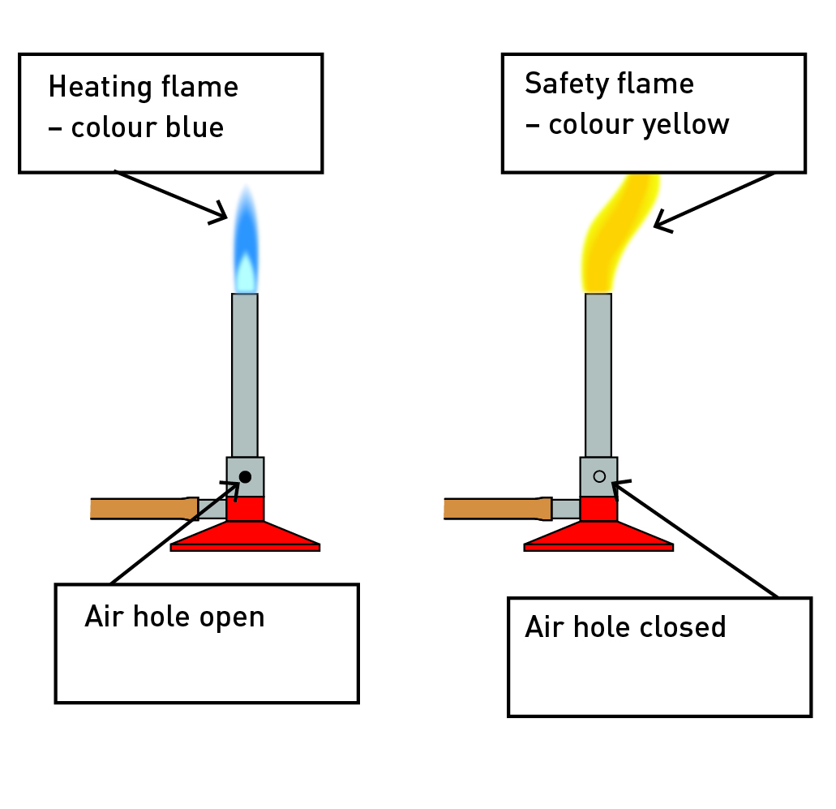

2 The descriptions below are the steps you should follow to light a Bunsen burner. Write the numbers 1 to 6 next to the appropriate description to indicate the order of the steps.

• Open the gas tap fully.

5

• Light a match and place it above the barrel, with your hand below the flame.

4

• Connect the rubber hosing firmly to the gas tap.

2

• Place the Bunsen burner on a heating mat.

1

• After you have followed these steps, the Bunsen burner will have a yellow flame.

6

• Close the air hole by turning the collar.

3

3

a LPG is naturally odourless (you cannot smell it). Why do you think the gas supply companies add substances like hydrogen sulphide (rotten egg gas) to the LPG?

LPG contains rotten egg gas so it can be smelled if there is a leak.

b What are two potential risks if the gas company did not add a smell to LPG?

Student response will vary but could include injury or death as a result of inhaling the gas and the potential for explosions because of a room filling with gas.

EXTEND YOUR UNDERSTANDING

4 Find out about the inventor of the Bunsen burner. Who was the inventor? When was the burner invented? What other discoveries or inventions did this person make?

Student responses will vary, but should include the following points:

• The Bunsen burner was invented by Robert Bunsen, a German chemist.

• The Bunsen burner was invented in 1855.

• Robert Bunsen also invented the hydro jet filter pump (a special water pump used to clean scientific samples), the photometer (a device used to measure the intensity of light), and the Bunsen battery (a chemical battery).

1.7 A fair test is a controlled experiment

Student worksheet answers (pages 16–17)

Controls

1 The following scenario describes a scientific investigation. Read the information and answer the questions.

Sue Doh liked to train for netball during the summer and wanted to know what coloured shirt would keep her the coolest. She decided to conduct a series of experiments to find out the answer. Sue assumed that white coloured clothes would be best because her mum’s white car was cooler inside compared with her dad’s dark coloured car. She found five different coloured squares of cotton cloth (white, purple, red, black, yellow and green). During the next really hot, sunny day she put squares of cloth on the trampoline in the backyard and put a thermometer underneath each cloth. She recorded the initial temperature of the five thermometers and the temperature on a thermometer lying on the trampoline but not under any cloth. She waited 5 minutes and wrote down the temperatures on all the thermometers. Sue decided to repeat her experiment three more times and recorded this information in a table of results for further analysis.

a What was Sue’s hypothesis?

Sue’s hypothesis was ‘If the fabric is a lighter colour, then I will not get as hot’.

b What was the independent variable in Sue’s experiment?

The independent variable is the colour of the cloth.

c What was the dependent variable in Sue’s experiment?

The dependent variable is the temperature measured under each of the different cloths.

d What variables were controlled in Sue’s investigation?

The variables that were controlled were the positions of the cloths and thermometers, and the length of time.

e How did Sue attempt to improve the reliability of her investigation?

Sue repeated the experiment three times to improve the reliability of the results.

f Was Sue’s experiment a fair test? Why or why not?

Student responses may vary.

g How could Sue’s experiment be improved so her results are more reliable?

Student responses may vary, but could include different positioning of the cloths, reducing the effect of any breeze and performing the experiment more times.

2 The following scenario describes a scientific investigation that a student, Con Trollé, conducted at home. Read the information and answer the questions.

Con wants to discover whether eating chocolate biscuits after school will affect the amount of food someone eats at dinnertime. To find out, Con chose four people to be test subjects. For 3 days, he will give them three chocolate biscuits after school. He will serve the same food for dinner for those 3 days and the test subjects will eat dinner at the same time every day. After 3 days of eating biscuits after school, he will then have the people have dinner for 3 days without eating biscuits after school. The test subjects will still have the same food for dinner and also eat at the same time. Con will measure and compare how much food they eat in the 3 days after eating biscuits and in the 3 days on which they didn’t have any biscuits.

a What is the independent variable in Con’s investigation?

The independent variable is the different test subjects.

b What is the dependent variable in Con’s investigation?

The dependent variable is the amount of food the test subjects ate for dinner.

c What are the controls in Con’s investigation?

The controls are the number of biscuits, the type of food eaten and the time the food was eaten.

EXTEND YOUR UNDERSTANDING

3 Phrenology is regarded as a branch of pseudoscience (meaning it has no real scientific foundation and isn’t based on evidence). Find out:

a what Phrenology was

Phrenology was the study of the size and shape of (i.e. the bumps on) people’s skulls. These measurements were used in an attempt to determine and predict people’s intelligence and certain personality traits.

b when it originated

Phrenology originated in the late 1700s (possibly 1796).

c what practitioners of Phrenology did

Practitioners of Phrenology would feel the size and shape of their patients’ skulls – in particular the bumps on the skull – to ‘diagnose’ health problems and personality traits. They would sometimes even predict their patients’ futures based on this.

d whether there was any scientific merit to this pseudoscience.

Phrenology was very popular around the world up until the 20th century. Despite the fact that many ‘scientific’ studies were conducted on patients during the 17th and 18th centuries, all of these have now been discredited. There is no scientific merit to Phrenology.

1.8 Graphs and tables are used to show results

Student worksheet answers (pages 18–21)

Displaying results

1 Use the data in the results table to complete an appropriate graph in the space provided.

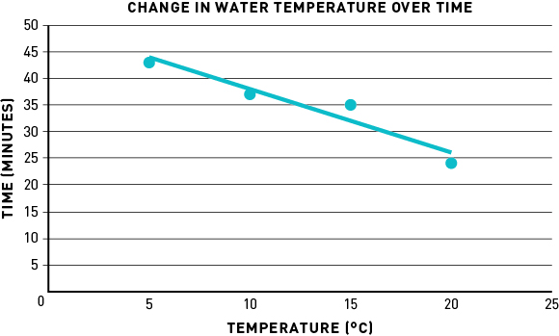

a What is the dependent variable?

Temperature

b What is the independent variable?

Time intervals

2 Examine the graph below and answer the following questions.

a What type of graph is this?

This is a column graph.

b Write an appropriate title for this graph.

A possible title could be ‘Number of insects caught at different locations’ or similar.

c What is the dependent variable?

The dependent variable is the number of insects caught.

d What is the independent variable?

The independent variable is the location of capture.

e Which location had the highest number of insects caught?

B

f Which location had the lowest number of insects caught?

H

g How many insects were caught at location:

i C?

15

ii D?

50

iii G?

20

EXTEND YOUR UNDERSTANDING

3 Use the Internet to find out:

a What is a pie chart?

To create a pie chart, a circle is divided into sectors representing a proportion of the whole.

b How could a pie chart be used to show the ‘insects caught’ data above?

To show the ‘insects caught’ data, the values could converted into percentages (by dividing the number of bugs caught at each location by the total number of bugs caught × 100) and the circle divided into sectors representing each of these percentages.

1.9 Scientific reports communicate findings

Student worksheet answers (pages 22–23)

Reporting

1 Trying to remember the eight parts of a scientific report can be a challenge at first. A way to remember the eight parts, and the order they come in, is to create a mnemonic (using the first letter of each word to create new words to form a sentence). For example, *Tiny Ants Healed Moths Meanwhile Rats Drew Cats*: ‘tiny’ for ‘title’, ‘ants’ for ‘aim’, and so on.

Write your own mnemonic next to the eights parts of a scientific report listed below:

Student responses will vary depending on the mnemonic

2 What are two reasons to write a method?

The method is important so you can plan what is to be done. In addition, it is important to provide the method in the formal report so that people can see exactly what you did and the order in which you did it.

3 How are results usually displayed?

Results are usually displayed in a table, graph or diagram.

EXTEND YOUR UNDERSTANDING

4 Research what a real bungee cord is made out of and how the operators adjust the cord depending on the weight of the jumper.

• Bungee cords are made out of thousands of elastic strands (usually made of rubber or latex) bound together and covered in a nylon fabric

• Depending on the weight of the jumper, bungee operators will make the bungee cord longer or shorter. Lighter jumpers usually require a longer cord and heaver jumpers usually require a shorter cord (as the cord stretches more under their weight).

1.10 Science as a human endeavour: Science skills are used to solve important problems

Student worksheet answers (pages 24–25)

Human endeavour

1 Design a simple experiment that scientists could conduct now that could investigate methods to control the carp population in the waterways of the Murray–Darling Basin.

a What is the aim of your experiment?

Student responses will vary, but should relate to control of the carp population.

b What are three questions you could ask yourself before starting the experiment?

Student responses will vary, but could include: location of the carp, methods used to control carp, predators, etc.

c Write a hypothesis based on one of your three questions.

Student responses will vary.

d What experiment could you conduct to investigate your aim?

Student responses will vary, but should relate to control of the carp population.

e Write some of the equipment you may need to conduct the experiment.

Student responses will vary.

f How would you record your results?

Student responses will vary, but a table would be appropriate.

g How would you present your results?

Student responses will vary, but a graph and diagrams would be appropriate.

h What type of information would you include in your conclusion?

Student responses will vary, but they should be clear, reasoned and relate to the initial aim.

EXTEND YOUR UNDERSTANDING

2 Conduct further research about the impact of the European carp to assist with your responses to the questions in this worksheet. The following weblink is a useful place to start your research: <http://www.dpi.nsw.gov.au/fisheries/pests-diseases/freshwater-pests/species/carp/general-information>

Student responses will vary, but they should include information that is relevant to their investigation.